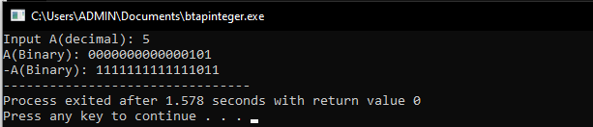

- What percentage of the work is done?
45%, I guess

